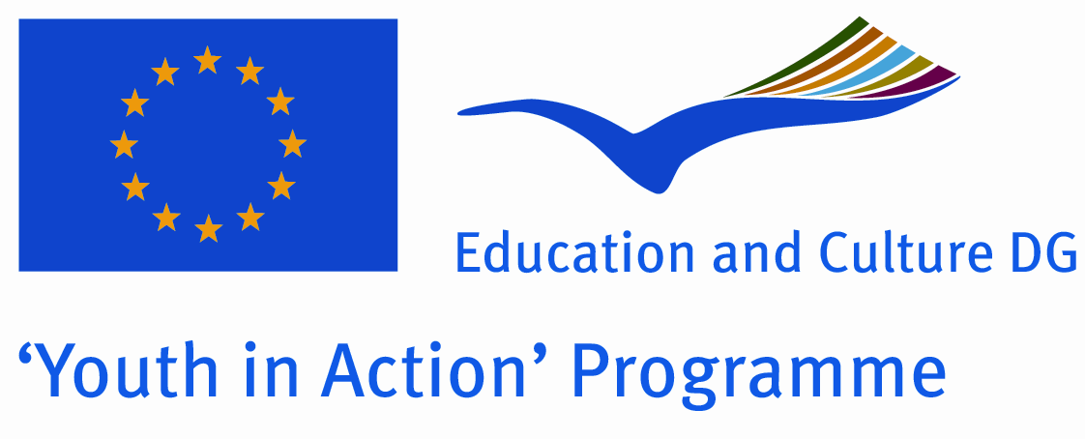

Action 3.1 ‘!Learn Green’

Theme: Linked to one of the priorities of the YiA program for 2012 (climate changes and environmental issues), Concordia invites you to take part in this training aiming at raising awareness and building capacity of participants as ‘sustainability ambassadors’ in order to enable to implement projects, disseminate information, educate others acting as multipliers in their own organizations. At the same time the training deals with sharing and developing new tools in the framework of the ‘Sustainability Campaign’ promoted by the members of the Alliance of voluntary service organizations.

Countries involved: France, Italy, Serbia, Iceland and Greece

Dates: 23rd (Arrival day) - 30th (Departure day) September 2012

Venue: Rhône Alpes - South of France (the venue has to be confirmed)

SURNAME: |  |  | Firstname:
Phone number: |  |  | Mobile :
Email :
Present adress: |  |  | Permanent adress / Adresse permanente (ex. : Parents) :
STREET |  |  | STREET
STREET |  |  | STREET
ZIP CODE | TOWN |  | ZIP CODE |  | TOWN
STATE - COUNTRY |  |  | STATE - COUNTRY
Gender: |  | Age : |  | Birthdate :
Nationality : |  |  | Birthplace :
Sending organisation: ELIX - Conservation Volunteers

Why would you like to take part in this training?

What are your expectations about this training?

Can you describe your previous education and your professional experiences and / or voluntary work ?

Where do you see yourself in the future?

Do you have any health problems (e.g. allergies) or handicaps ? Special needs ?

Emergency contact :

NAME : Phone number:

Association CONCORDIA
64 rue Pouchet – 75017 PARIS
FRANCE

